1
Ex. No: 09 | ACCESSING APIs THROUGH HTTP
Date of Exercise | 22.09.2026
Git-hub Host Link | https://github.com/Urk23cs1226/flutterlab.git

Aim:
To access a REST API using HTTP and retrieve and display JSON data in a Flutter application.

Description:
This experiment demonstrates how Flutter communicates with a REST API using the http package. The application sends a GET request to the JSONPlaceholder API, converts the JSON response into Dart data, and displays the posts using ListView.builder. Loading and error states are also handled.

Procedure:
Step 1 : Create Flutter Project - flutter create api_app
Step 2 : Add HTTP Package - Add http under dependencies in pubspec.yaml, then run:
Step 3 : Import Packages dart:convert for JSON decoding and the http package for API requests. Step 4 : Create API Function Create a function using http.get() to retrieve data from the
JSONPlaceholder REST API.
Step 5 : Decode JSON Data check the response status and convert the JSON response into Dart data using jsonDecode().
Step 6 : Display API Data Store the retrieved posts in a list and display the title and body of each post using ListView.builder().
Step 7 : Add Loading Display a loading indicator while the API data is being fetched. Step 8 : Display an appropriate error message when the API request is unsuccessful
Step 9 : Test the Application Run the application in Chrome and verify that the API posts are displayed correctly.
Step 10 : Deploy to GitHub Pages - Build and upload the Flutter web application to the GitHub repository exp9-api-flutter and enable GitHub Pages using GitHub Actions.

Program:
import 'dart:convert';
import 'package:flutter/material.dart'; import 'package:http/http.dart' as http;
void main() { runApp(const ApiApp());
}

class ApiApp extends StatelessWidget { const ApiApp({super.key});

@override
Widget build(BuildContext context) { return MaterialApp( debugShowCheckedModeBanner: false, title: 'API App',
theme: ThemeData(
scaffoldBackgroundColor: const Color(0xFFF8F4FC), colorScheme: ColorScheme.fromSeed(
seedColor: const Color(0xFF9C7AC7),
),
appBarTheme: const AppBarTheme( backgroundColor: Color(0xFFBFA2DB), foregroundColor: Colors.white, centerTitle: true,
elevation: 2,
),
cardTheme: const CardThemeData( color: Color(0xFFF0E6F7), elevation: 2,
margin: EdgeInsets.symmetric( horizontal: 12,
vertical: 7,
),
),
),
home: const ApiHomePage(),
);
}
}

class ApiHomePage extends StatefulWidget { const ApiHomePage({super.key});

@override

State<ApiHomePage> createState() => _ApiHomePageState();
}

class _ApiHomePageState extends State<ApiHomePage> { List<dynamic> posts = [];
bool isLoading = true; String errorMessage = '';

@override
void initState() { super.initState(); fetchData();
}
Future<void> fetchData() async { setState(() {
isLoading = true; errorMessage = '';
});

try {
final response = await http.get( Uri.parse(
'https://jsonplaceholder.typicode.com/posts',
),
);

if (response.statusCode == 200) {
final data = jsonDecode(response.body);

setState(() { posts = data;
isLoading = false;
});
} else { setState(() {
errorMessage = 'Failed to load data'; isLoading = false;
});
}
} catch (e) {
setState(() {
errorMessage = 'Network error. Please try again.';

isLoading = false;
});
}
}

@override
Widget build(BuildContext context) { return Scaffold(
appBar: AppBar( title: const Text( 'REST API Posts',
style: TextStyle(
fontWeight: FontWeight.bold,
),
),
),

body: isLoading
? const Center(
child: CircularProgressIndicator( color: Color(0xFF9C7AC7),
),
)
: errorMessage.isNotEmpty
? Center( child: Column(
mainAxisAlignment: MainAxisAlignment.center, children: [
const Icon( Icons.error_outline, size: 60,
color: Color(0xFF9C7AC7),
),
const SizedBox(height: 15),
Text( errorMessage,
style: const TextStyle( fontSize: 18,
color: Color(0xFF5E4A6E),
),
),

const SizedBox(height: 15),

ElevatedButton( onPressed: fetchData,
style: ElevatedButton.styleFrom( backgroundColor:
const Color(0xFFBFA2DB), foregroundColor: Colors.white,
),
child: const Text('Retry'),
),
],
),
)
: RefreshIndicator(
color: const Color(0xFF9C7AC7), onRefresh: fetchData,

child: ListView.builder(
padding: const EdgeInsets.symmetric( vertical: 10,
),
itemCount: posts.length,

itemBuilder: (context, index) { return Card(
child: ListTile( contentPadding:
const EdgeInsets.all(12),
leading: CircleAvatar( backgroundColor:
const Color(0xFFD8C4E8),
child: Text( '${posts[index]['id']}', style: const TextStyle(
color: Color(0xFF5E4A6E), fontWeight: FontWeight.bold,
),
),
),

title: Text( posts[index]['title'],

style: const TextStyle( color: Color(0xFF4D3A5C),
fontWeight: FontWeight.bold, fontSize: 16,
),
),

subtitle: Padding(
padding: const EdgeInsets.only( top: 8,
),

child: Text( posts[index]['body'], style: const TextStyle(
color: Color(0xFF6E5A7D), height: 1.4,
),
),
),
),
);
},
),
),
);
}
}

6

Output:
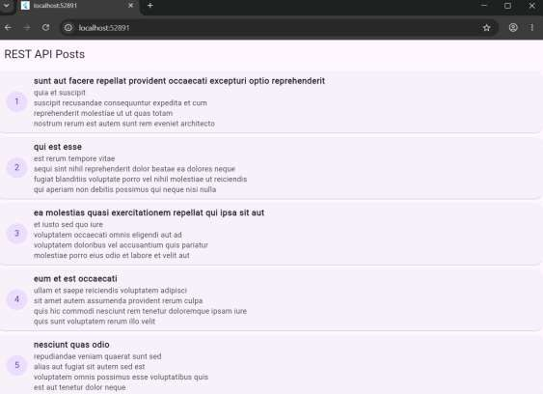
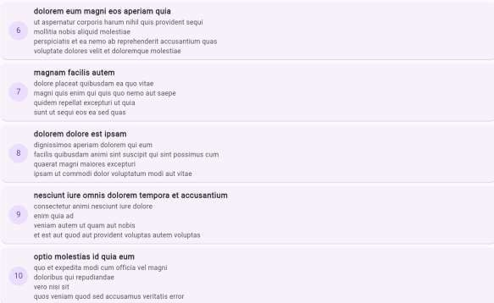

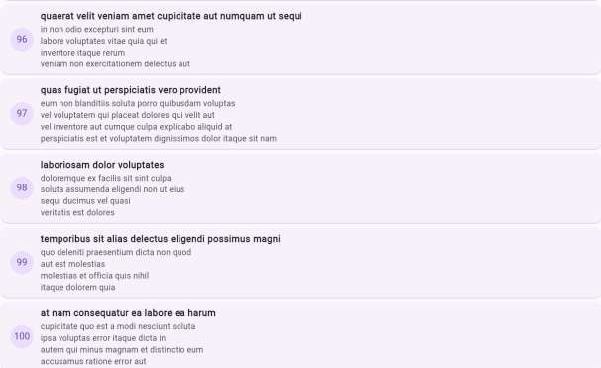

RESULT
Thus, The Flutter application successfully accesses a REST API using the HTTP package, retrieves JSON data from JSONPlaceholder, converts the response into Dart data, and displays the posts in a scrollable UI with loading and error handling.

